V

“There is no greater bond among men, than those who share danger.” Henry David Thoreau
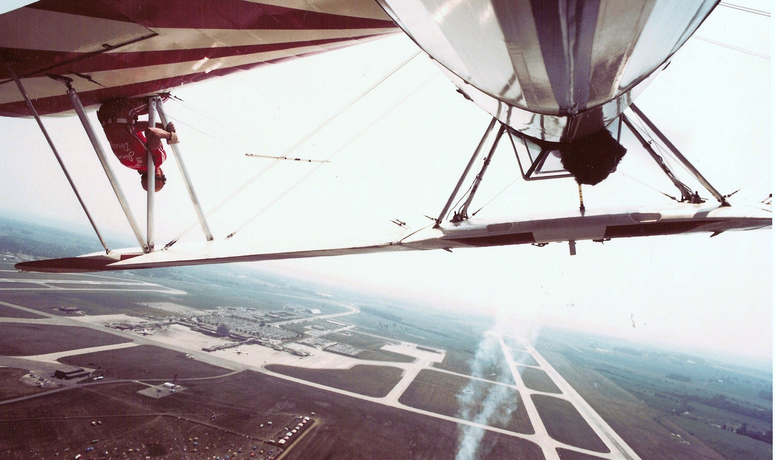

Bob

TWO BOB’S – LYJAK & BARDEN

Bob Lyjack & Bob Barden, Sr. 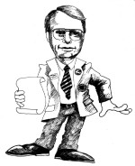
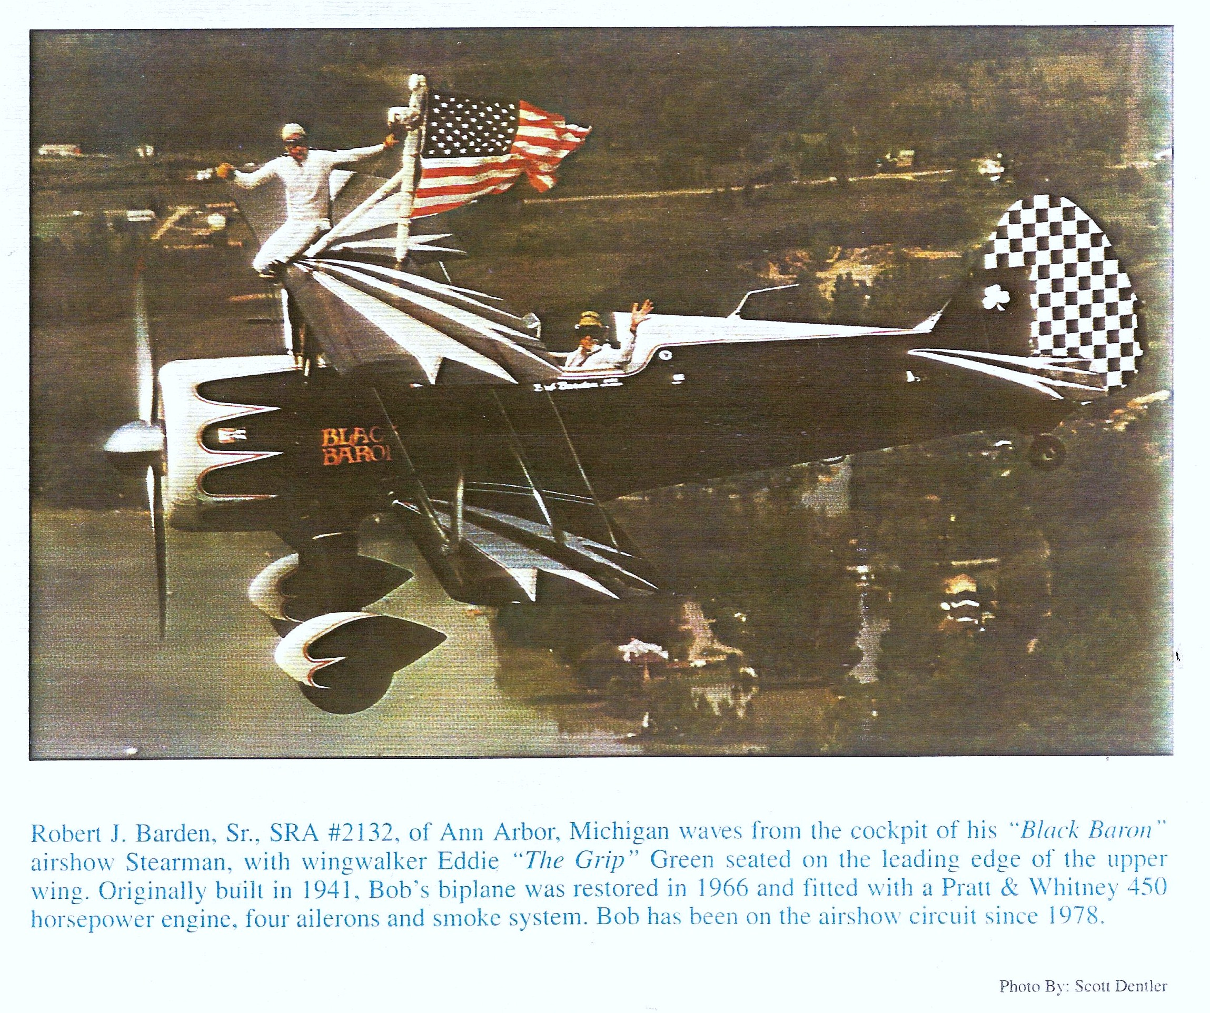
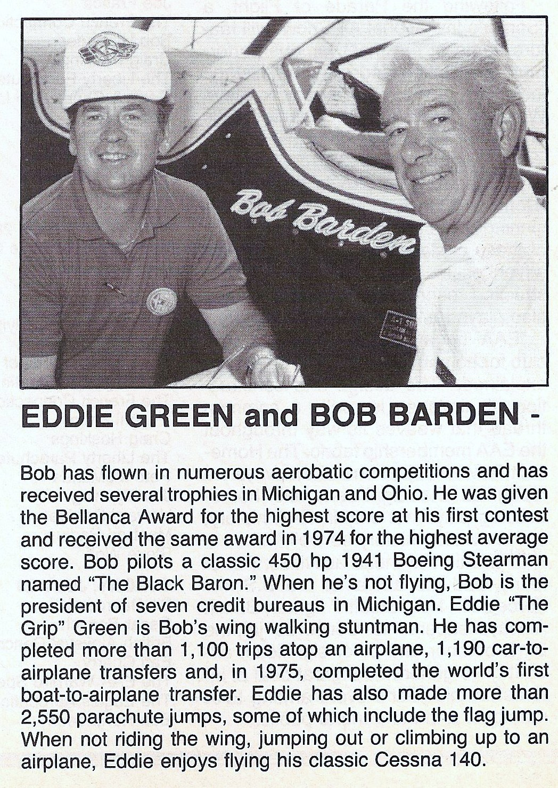

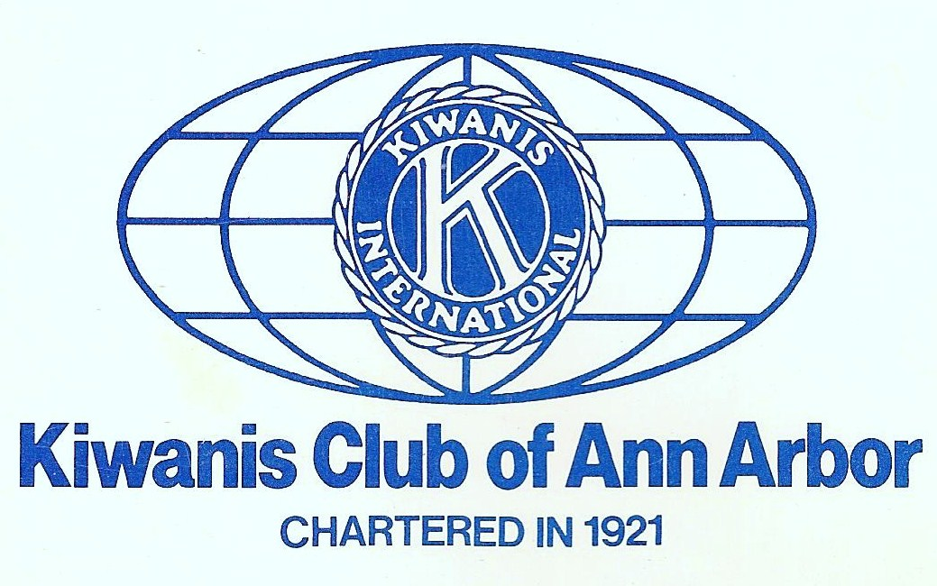
A2 Air Force
Bill Barber* Bob Barden,Sr. Danny Clisham Eddie “The Grip” Green Bob Lyjak Jim Mynning
*deceased Bob Barden, Sr.

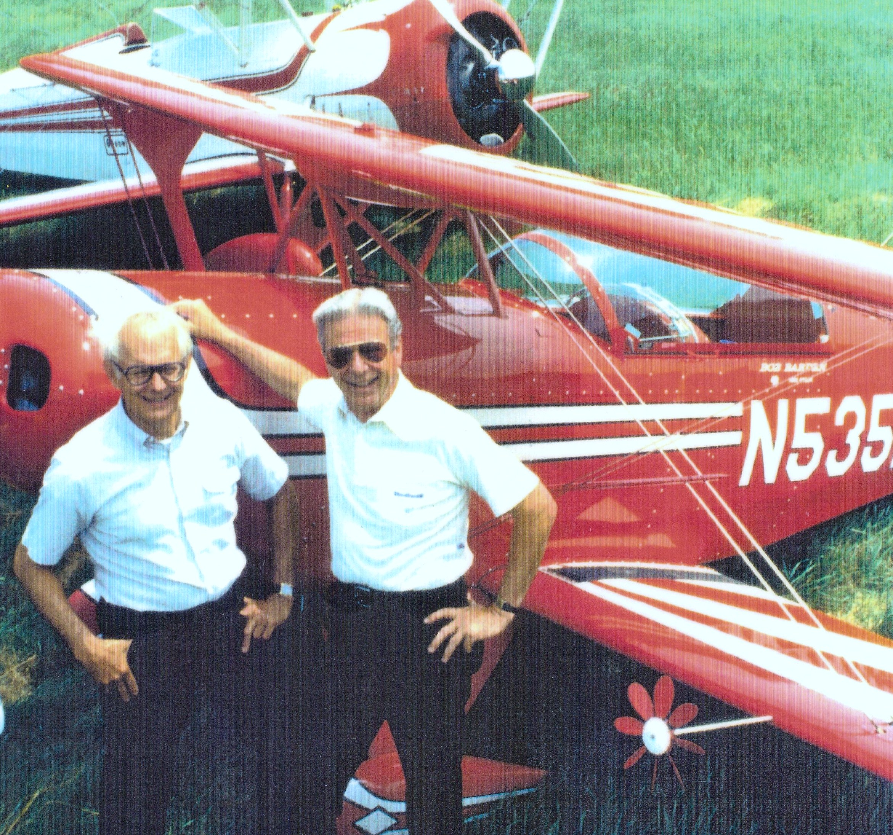
Robert J. Barden, Sr. Joined in 1961 President, 1971 Hall of Honor “Bob is our only member to father two past presidents, Kathy and Bob Jr.”

- Hall of Honor “Bob is the only father-member in the history of

