Keith Curtis Memorial
Police Officer Of The Year
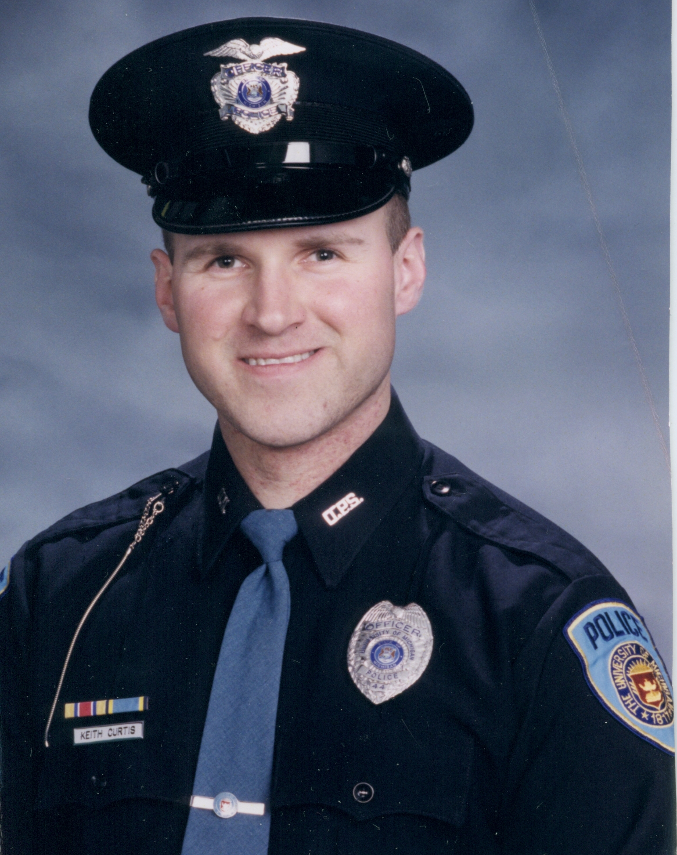
Keith Curtis
1969-2002

This is the third year a Police Officer of the Year is being recognized by the Department. All sworn officers, regardless of rank, were eligible for consideration. Nomination criteria included leadership, integrity, respect, loyalty and commitment. Ultimately, the officer was chosen by a vote of the police personnel.

This year’s nominees are:
Officer Kevin Crowley

Officer David Hawkins

Officer Mark West

The award has been named in honor of Keith Curtis, a beloved officer of the department who died in January 2002 after a courageous battle with leukemia. Keith joined the department in March 1995 and served as a bicycle officer and Community Oriented Policing officer. He exemplified the many qualities of an outstanding Police Officer. A husband and father of two girls, Keith loved helping the U-M community and was considered a true professional and a gentleman.

The 2009 recipient was Officer Susan Upton and 2010 recipient was Officer Pete Pressly.



University of Michigan

Department of Public Safety

Awards Ceremony

Kipke Conference Center
Campus Safety Services Building
May 11, 2011

Today’s Program

Presentation of Colors U-M DPS Honor Guard

National Anthem Officer Joanne McAllister

Welcome Michael Armitage
Police Communications Specialist
and Master of Ceremonies

Awards Sergeant Pat Alessi

Sergeant Robert Soichet
Awards Board

Director’s Awards Interim Chief Joe Piersante
Kathleen Donohoe – U-M Staff
Susan Kaufmann – U-M Staff
Staff at Huron Valley Ambulance

Police Communications Specialist of the Year

Professional of the Year

Keith Curtis Memorial
Police Officer Of The Year

Police Communications

Specialist Of The Year
A new award in 2010, the Police Communications Specialist of the Year will recognize an individual from our E911 Center. Nomination criteria included leadership, integrity, respect, loyalty and commitment. The 2010 recipient was Brook Miller.

This year’s nominees are:
Scott Cook Lisa Houston

Professional Of The Year
For the second year, the Department is recognizing a civilian individual for outstanding contributions to DPS and the University. Nomination criteria included outstanding performance, respect, professional practice, leadership and customer service. The 2010 recipient was Scott Cook.

This year’s nominees are:
Michael Pomorski Pearl Romberg

2010 Employee of the Quarter
Each quarter, the department recognizes one individual who in the performance of duty consistently demonstrates dependability and a commitment to the department’s mission, vision and key values. Those so recognized in 2010 were:
Officer Milot Goci Diane Brown
PCS Lisa Houston Officer Matthew Butzky

Embezzlement
Outstanding Public Service Award –
Lt Charles McDermott, Housing Security
Professional Excellence Citation – Ofc Margie Pillsbury, DPS

Armed Robbery
Outstanding Public Service Award –
Ofc Scott Cutcher, Housing Security
Professional Excellence Citation –
Sgt Chris Carelli, DPS
Sgt Stacy Richmond, DPS

Assault
Professional Excellence Citation -- Ofc Michael Mathews, DPS

Medical Crisis
Outstanding Public Service Award –
Ofc David Taylor, Housing Security
Professional Excellence Citation-- Ofc Matthew Butzky, DPS

Traffic Crash
Public Safety Award (Citizen) – Douglas Schaubel, U-M faculty

Medical Crisis at Couzens Hall
Public Safety Award (Citizen) – Ofc Lisa Clark, Housing Security
Certificate of Commendation – Ofc Pete Pressly, DPS
Meritorious Service Citation – Ofc Matthew Butzky, DPS

Armed Robbery
Outstanding Public Service Award – Cory Simonds, U-M student
Unit Citation for Professional Excellence –
Ofc Akin Bryant, DPS
Ofc Ryan Cavanaugh, DPS
Ofc Orlando Featherstone, DPS
PCS Steve Moss, DPS
Distinguished Service Citation – Ofc Milot Goci, DPS

Awards

Certificate of Commendation – Awarded to an officer who performs a service that is deemed both effective and unusually beneficial to the community or department

Crime Prevention Award (Citizen) – Presented to any individual or group who significantly contributed to the enhancement of crime or loss prevention thereby enhancing the safety and security of the Ann Arbor campus community

Director’s Award – Awarded by the Director for outstanding service to the department

Distinguished Service Citation – Awarded to an individual who performs an act in the line of duty, while knowingly endangering his/her life, or exposes him/herself to serious injury while saving a life, preventing a serious crime or apprehending a suspect of a serious crime

Law Enforcement Appreciation Certificate – Awarded to a member of another law enforcement agency who significantly contributed to the safety and security of the Ann Arbor campus community

Letter of Commendation (Citizen) – Presented to persons assisting the Department who would not be recognized in any of the other award categories, but went above and beyond the normal scope of his/her duties

Meritorious Service Citation –Awarded to an individual who, in the line of duty, through diligence and perseverance, performs difficult tasks under unusual circumstances going beyond what is normally expected where a crime is prevented, life or property has been protected, a criminal has been apprehended or an unsuccessful attempt was made to save a life under extraordinary conditions

Outstanding Public Service Award (Citizen) – Awarded for voluntary services that involved sacrifice to job or self while assisting the department

Professional Excellence Citation – Awarded to an individual for performance of a duty or assignment in a manner that is deemed highly effective, skillfully conducted and of exceptional benefit to the community or department

Public Safety Award (Citizen) – Awarded to a citizen who provided life-saving action or assisted an officer in the performance of his/her duty in an extraordinary fashion.

Unit Citation for Professional Excellence – Awarded to a group of personnel for performance, as a team, of a duty or assignment in a manner that is deemed highly effective, skillfully conducted and of exceptional benefit to the community or department

Years of Service
Five-year terms of service with DPS
Ten Years Twenty Years
Yvette Bailey Tom Dettling
Ofc John-Mark Branch Patty Lamsa
Ofc Jose Dorta Lt Jesse Lewit
Ofc Milot Goci I/C Joe Piersante
Ofc Heather McDonald Sgt Stacy Richmond
Brook Miller Jeff Rowe
Mike Pomorski
Ofc Garry Veld Twenty-five Years
Ofc David Dupuis
Fifteen Years Lt Robert Neumann
Ofc Brent Carriveau Paul Vaughan
Ofc Michael Mathews
Mary Mundt
Ofc Pete Pressly

Incidents
Larcenies at CCRB
Crime Prevention Award (Citizen) –
Tina Hanrahan, U-M staff
Adam Manning, U-M staff
Sara Walker, U-M staff

Larceny at Michigan Union
Crime Prevention Award (Citizen) –
Alex Hilliker, U-M student
Assoc Dir Declan Lugin, Housing Security

Larcenies at EECS
Crime Prevention Award (Citizen) – Kyle Lady, U-M student

Drug Diversion
Crime Prevention Award (Citizen) –
Ofc Nicholas Elliott, Hospital Security
Jennifer Suchyta, U-M Staff
Certificate of Commendation – Sgt Robert Soichet, DPS

Larceny &Assault at Markley Hall
Letter of Commendation (Citizen) –
Ofc Jennifer Bouchard, Housing Security
Certificate of Commendation –
Ofc Joseph Dunny, DPS
Ofc Nanette Push, DPS
Law Enforcement Appreciation Certificate
Dep John Cratsenburg, Washtenaw Co Sheriff

Drugs at Markley Hall
Outstanding Public Service Award –
Lt Charles McDermott, Housing Security

Hazardous Material Spill
Professional Excellence Citation – Ofc Bernard Mundt, DPS

